## XF

## Merchant : Notabene

Demo date: Mar 25, 2025  
Scoping start date: n/a

MSA Signature Date: Mar 26, 2025  
Onboarding Kick Off Date: Mar 28, 2025

[If Exists] Opt Out Date: none  
Go Live Date: Nov 14, 2024

GTM POC: Jarrett  
Implementation POC: Jane/ Jeff

ERP: QBO

Tax Integration: No Tax (Selecting between anorak and avalara)

### 

### Key persons:

### CFO: Alex Furer ([alex.furer@notabene.id](mailto:alex.furer@notabene.id))

### Billing Eng: : Richard Crosy [richard@notabene.id](mailto:richard@notabene.id)

### 

| Notes Sections [Ops International Team to Ignore] *(AE/ Implementation to fill)*   * Info on how merchant bills   + Notabene offers subscription-based services. Customers are billed in advance on a recurring and periodic basis, with billing cycles set either on a monthly or annual basis, depending on the selected subscription plan. At the end of each billing cycle, the subscription automatically renews under the same conditions unless canceled by the customer. To initiate a subscription, a valid payment method, such as a credit card, is required. Notabene also offers a free trial period for their services, after which, unless canceled, the subscription transitions into a paid plan. * Is there any important merchant relationship information?  1) What is the merchant temperament?   Collaborative and eager to move quickly. Rishard is the tech skeptic, while Alex is more of a futurist. They understand that they have a unique billing model and are often willing to adapt business practices to better align with Tabs' functionality.  2) Is there a key POC: (i.e.: who is the buyer/decision maker?)  Alex Furer  3) What are the Tabs features that the key POC cares about? -Tabs API  -Reporting  -Very important that Tabs <> Stripe Data unity and how that reporting is done |
| --- |
|  |

### Company summary *(AE to fill)*

Summary of what company does: ​Notabene is a company founded in 2020 that specializes in cryptocurrency compliance solutions, particularly focusing on helping businesses adhere to the Financial Action Task Force's (FATF) Travel Rule. Their platform enables financial institutions and crypto businesses to manage regulatory and counterparty risks in crypto transactions. Key features of Notabene's SafeTransact platform include real-time decision-making automation, counterparty sanctions screening, self-hosted wallet identification, and seamless Travel Rule compliance aligned with global and local regulations. ​

Goals (North star)  
*(AE/ Implementation to fill)*

What is the merchant's goal? What pain are we solving? Why are they buying Tabs?

Is there an opt out clause? If so, what is the merchant looking for so they do not exercise it?

None

### Billing model *(AE/ Implementation to fill)*

* Are there unique things about the customer creation process for this merchant?

Sometimes, they have self-customers that convert to paid subscription

* Information on how merchant bills

See Above

* One off things to know about the merchant

### Contract Processing Steps *(Implementation/Success to fill)*

1. Steps to process

Two types of contracts - please reference specific section based on the logo at the top of the contract

Fireblocks

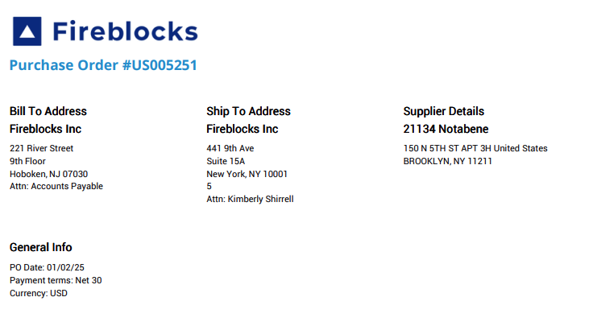

Notabene

Everything else - contracts have different formats/headers. Some examples below:

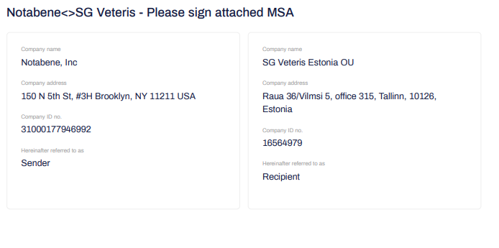

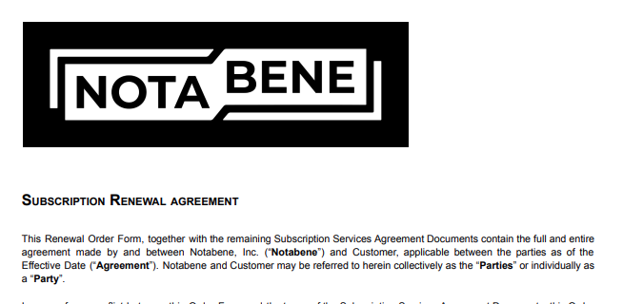

## NOTABENE

**Locate billing terms (BTs)** in the Order Form of each contract. Common terms include:

* 1. Subscription/Platform Fee (e.g., Transaction Compliance Platform)
  2. Transaction packages (XXS, Starter, etc.)
  3. Set-Up Fees (if any)
  4. Overage Fees (only include if pre-committed in the contract, meaning that there is an associated flat fee billing product that is being invoiced for)
     1. **Please double check that any product that is labeled “Additional [xyz]” is being billed as a UNIT BT and not Flat Fee. The AI has messed that up before**

1. **Service Start Date**:
   1. “Effective Date” or “Order Start Date”
2. **Months of Service**:
   1. Use full contract term in months (e.g., 12 for annual, 36 for 3-year)
   2. If not stated clearly, calculate from start/end dates listed in Order Form
3. **Billing Start Date**:
   1. Use "Billing Start Date" if listed explicitly (e.g., Amdax = Sept 12, 2024)
   2. If not stated, default to Effective Date/Order Start Date of the contract
4. **Frequency**:
   1. Check payment terms
   2. Annual = if billing happens once per year
   3. Quarterly = if "Payments per Year: 4" or quarterly surcharge listed
   4. Bi-annual = if explicitly stated (e.g., Amdax)
   5. Monthly = only if contract specifies 12 payments per year
5. **Periods:**
   1. Based on frequency and stated contract term
      1. E.g. if frequency is annual and term is 12 months, period would be 1
6. **Net Terms**:
   1. Default to Net 30 unless contract explicitly lists something else (e.g., "Payment Terms: Net [x]")
7. **Quantity**:
   1. Default to 1 unless other quantity shown
8. **Price**:
   1. Use annual or total fee listed in contract
   2. Split price across frequency if required (e.g., divide annual total by 4 for quarterly invoices)
9. **Integration Item Mapping**:

| **Product Name** | **Integration Item** |
| --- | --- |
| Additional Entities  Additional Entity  Additional Jurisdiction  Additional Notabene Suite  Additional seats  Entity Registration  Nested Entity Support | Additional Entities |
| Additional Consultation Services  SAML option for OKTA integration | Consulting Services |
| Customer enablement package  Enablement Package  Customer Success (+ anything)  Service Fee  Services Package | Customer Service Package |
| Discount (+ anything)  Annual Adjustments  SLA Concessions | Discount |
| Late Fees  Late Payment  5% Premium for Bi-annual billing  Jurisdiction Package | Misc Fees |
| Additional (+volume/transaction/etc)  Outgoing Transaction Overage  Outgoing Transfer Volume Overage  Overage (+anything) | Overage |
| Annual Cost  Annual Subscription  Annual Fee  Notabene Essential  Notabene Starter Pack  Notabene Suite  Platform Fees  Product License Fee  Product Package  Subscription Services  Suite  Transaction Compliance platform  Travel Rule | Platform Fees - default for any annual products |
| Setup (+ Fee/Total/etc)  Travel Rule Setup and Verification | Setup Fee |
| Quarterly Outgoing Transfer Volume | Transaction Dollar Volume |
| (size +) Transaction Package | Transaction Package |

1. **Overage BT**:
   1. Only process as BT if the contract includes pre-purchased units as part of a flat fee product
   2. Example: 10,000 transactions at $0.30 overage rate — do not list overages unless commitment to a transaction package is made
   3. In the example below: transaction package is a BT and “additional incoming and outgoing transactions” should be processed as a separate tiered usage based BT because transaction package (flat fee) is being billed for
      1. **The AI will produce a unit based BT which you will have to transform into a tiered unit product to account for the included transactions**
      2. **For example, first 300,000 transactions are included in the package and should have unit price of $0**
      3. Additional jurisdictions should also be a usage BT because it is included as part of the Product Package. Product would be tiered unit, charged for over 1 jurisdiction



* 1. Billing frequency - follow overage cadence if listed explicitly, otherwise match cadence of the flat BT
     1. In the example below (b41b46dd-6c3c-4c1d-a203-5770ad891897), circled in blue is the flat fee billing cadence (once) and in pink is the usage frequency (monthly, in arrears)



## FIREBLOCKS

These contracts are different from their previous ones because they're Fireblocks reseller contracts

Customer Creation:

* We can set these up as direct customers with Fireblocks in the name (ie. Fireblocks - Customer Name; this one would be "Fireblocks - Brittania")
* The customer name is the first line in the invoice that's bolded (looks like what you'd expect to be a product - in this [example](https://drive.google.com/file/d/1PyWfVk4Lfi8Y5qGEZr3FxYlUo5L3DXdg/view) it would be Brittania)

Billing and shipping info:

* Billing address: use "Bill to Address"

Shipping address:

* use "Shipping/Delivery Address in the description of the product"
* e.g. UNIT 6 WESTERN BUSINESS, CENTRE WESTERN ROAD
* Client Primary Contact: Ivan Mistretta, imistretta@britannia.com

Creating BT:

* Individual products are listed in what looks like the description
* Main product name: Notabene Suite
* Integration item: platform fees
* Price: total price from PO
* They still want to create the other products, but assign all products except the Notabene Suite $0.00

ex. from the Britannia PO [attached,](https://drive.google.com/file/d/1PyWfVk4Lfi8Y5qGEZr3FxYlUo5L3DXdg/view?usp=drive_link) we'd create products with $0 price for:

* Customer Success Solis: 1
* Additional Notabene Suite: 1
* Transaction Package XXS (10,000 Annually): 10,000
* And product with unit rate for:
  + Annually Overage Rate: $0.21/tx
  + Subscription Start and End Date: also noted in the description (use for billing dates as well)
  + Billing timing: arrears
* [Here](https://drive.google.com/file/d/1OXb5xyrEnhTTCKEVLIq8Ca1YBgWjQCAI/view?usp=drive_link) is the resulting invoice from the PO to help put their instructions above in context.

1. Anything to ignore in contracts?
2. Specifics processing things the merchant has requested that may differ by contract (e.g. always back-date invoice date to final day of the month)
3. Default Service Term
   1. If None Listed, Ops Default is 1 Year
4. Default Net Payment Terms
   1. If None, Ops Default is 0
5. Default Billing Frequency
   1. If None Listed, Ops Default is Monthly
6. How do we handle taxes as a line item?
   1. If None Listed, Ops Default is every tax line item becomes a BT

### Events Processing (if necessary) *(Implementation/Success to fill)*

* Any important information on events billing

Integration Items Processing (if necessary)  
*(Implementation/Success to fill)*

* What are the instructions for assigning integration items?
* Example: All Statsig integrations items should be labeled as “Sales”
* Example: All “Pinata” integration items should be labeled as “Software Subscription Bundle” unless otherwise noted by Merchant

Post Processing Communications (if necessary)  
*(Implementation/Success to fill)*

* Does the Ops Team need to notify anyone on the team re: completion of processing batches in Implementation or Active phase?
* Who needs to be notified and when?
  + Example:
    - Who: Customer Success [Azmat Aziz] needs to be notified
    - Where: Messari internal merchant channel
    - When: contracts are processed [Merchant Phase: Active]

### Customer Information *(Implementation/Success to fill)*

* Any important information on specifics customers of this merchant
  + Special memo’s certain invoices require
  + Invoice changes due to merchant/customer relationship

### Feature Requests *(AE/Implementation/Success to fill)*

* Stripe <> Tabs Dats connection

### Rewatch Calls *(AE/Implementation/Success to fill)*

* <https://us-56595.app.gong.io/call?id=109501754356657044&account-id=8128027842368128660>
* <https://us-56595.app.gong.io/call?id=3994651365793882433&account-id=8128027842368128660>  
  <https://us-56595.app.gong.io/call?id=1159928221061712537&account-id=8128027842368128660>  
  <https://us-56595.app.gong.io/call?id=1168442837289550912&account-id=8128027842368128660>

**Overview of the Deal**

Notabene, a crypto-related company, is transitioning from Chargebee to Tabs to address critical pain points in their billing, revenue recognition, and operational workflows. The sales process began in February 2025 and progressed through multiple discussions with key stakeholders—Alex Furer (Head of Finance) and Richard Crosby (Head of Engineering)—culminating in a tentative commitment contingent on addressing technical and operational concerns. The goal is to finalize commercials by the end of Q1 2025 (March 31, 2025) and begin implementation in April-May 2025, with flexibility for June if needed.

Tabs has positioned itself as a flexible, AI-native revenue automation platform to solve Notabene’s B2B sales-led growth (SLG) challenges while integrating with Stripe for their product-led growth (PLG) motion. The deal emphasizes minimizing engineering lift, providing a single source of truth for financial data, and supporting innovative pricing experimentation.

---

**2. Key Stakeholders and Temperament**

**Alex Furer, Head of Finance**

**Background:** At Notabene for ~4 months as of March 2025; experienced across health tech, fintech, consumer products, prop tech, and now crypto. Previously with Plaid (“Plaid mafia”).

**Temperament**: Pragmatic, time-constrained, and focused on operational efficiency. Alex is frustrated with manual billing tasks (e.g., spending 45 minutes per contract setup or 3 hours rewriting invoices) and values solutions that reduce his workload. He’s collaborative but cautious about forcing decisions on engineering (Richard), preferring to build consensus. He’s under pressure from an upcoming board meeting (week of March 24, 2025) and an industry conference (prior to March 21, 2025).

**Priorities**: Flexibility in pricing/business models, single source of truth for finance, ease of admin, and minimal time investment. Wants Richard’s buy-in to avoid implementation delays.

**Key Quote:** “I’d rather not have to spend three hours rewriting an invoice every time I have to do it… I’d rather make [Richard] a promoter of the service.” (March 21, 2025)

**- Richard Crosby, Head of Engineering**

- **Background**: With Notabene since its early customer onboarding phase; based in Berlin (originally from the UK). Oversees engineering and infosec.

- **Temperament**: Analytical, cautious, and focused on data integrity. Richard is wary of dual-system setups (e.g., current Stripe + Chargebee pain) and wants a unified solution to simplify engineering efforts. He’s open to Tabs but skeptical about managing PLG (Stripe) and SLG (Tabs) separately, fearing operational complexity. He’s technically savvy and seeks clear API documentation.

- **Priorities:** Simplified billing integration, data consistency, and minimal engineering overhead. Concerned about PLG-to-SLG customer transitions and entitlement tracking.

- **Key Quote:** “Not being able to consolidate all of our subscriptions under a single provider is going to be really tricky for us.” (March 18, 2025)

**- Tabs Team Involvement:**

- Arjun Gopalratnam (Head of Product):Engaged on API/entitlements; available for Richard’s technical queries.

-Deepak Bapat (CTO/Co-Founder): Handled early technical discussions; oversees infosec.

- Jon Tsay (Product Manager): Focused on Stripe integration design; seeks Notabene input as a design partner.

---

**3. Current Notabene Tech Stack and Processes**

Billing Platforms:

- **Chargebee:** Primary AR solution; inflexible, structured data model limits pricing experimentation and usage tracking. Operational pain points include invoicing, revenue recognition, and overage calculations.

- **Stripe:** Used historically (pre-Chargebee) and currently for some PLG/free plans; holds legacy data. Lacks SLG support but is developer-friendly.

**- Other Systems:**

- **QuickBooks**: General ledger for financial reporting.

- **HubSpot CRM:** integrations with Chargebee and contract vendors are unreliable.

- **Coupa:** Used for reseller billing (e.g., uploading invoices to reseller instances).

- **Data Warehouse/BI Tool:**  Unspecified, but they plan to pull data into a BI system.

- **Current Billing Process:**

- **Contracts:**  Manually ingested into Chargebee; complex pricing (e.g., 22-month co-terminated contracts) requires custom product setups, taking Alex 45+ minutes per contract.

- **Usage Tracking**: Engineering preprocesses transaction data (volume-based in USD or count-based) before reporting to Chargebee/Stripe, requiring custom solutions.

- **Invoicing:** Slow and error-prone; resellers send POS data without order forms, complicating tracking. Rewriting invoices (e.g., wrong email, new date) is a “pain in the butt.”

- **Revenue Recognition:**  Fragmented across Stripe and Chargebee, lacking a unified view.

- **Tax:** No vendor currently; exploring Avalara or Anrok (TaxJar insufficient internationally).

**- Product Structure:**

- PLG: Free and starter plans on Stripe; customers upgrade via product dashboard.

- SLG: Enterprise plans with transaction packages (e.g., $10M volume or 1M transactions) and jurisdiction-based pricing (prorated, co-terminated).

- Resellers: Parent-child relationships; tracked as separate customers despite billing to one entity.

---

**4. Notabene’s Pain Points and Requirements**

- **Operational Inefficiency:** Manual billing tasks overwhelm Alex; Chargebee’s rigidity hampers pricing flexibility and automation.

- **Data Fragmentation:** Stripe + Chargebee duality causes operational pain; Richard fears a Tabs + Stripe repeat.

- **Usage Tracking:** Engineering struggles with overage calculations (transaction volume vs. count) and jurisdiction proration.

- **PLG-to-SLG Transition:** Richard worries about customer record consistency and portal functionality loss when moving from Stripe to Tabs.

- **Entitlements:** Product needs to toggle features (e.g., jurisdictions) based on contract terms; currently poorly implemented in Chargebee.

- **Tax Compliance:** Requires international capabilities (Avalara/Anrok preferred).

- **Reporting:** Needs live ARR, booked ARR, and revenue by customer (including reseller children).

---

5. Tabs Product Commitments

**Core Platform:**

- Hyper-flexible, AI-native revenue automation to ingest contracts, extract terms, and automate billing/invoicing.

- Single source of truth for SLG revenue recognition, ARR, and GAAP metrics; integrates with QuickBooks.

- Unlimited seats, flat-fee pricing, no revenue percentage; includes implementation (no service fees).

**- Stripe Integration (PLG):**

- One-click integration to pull Stripe customers, invoices, and revenue into Tabs for a unified financial view.

- Supports hybrid PLG models (e.g., monthly fee + transactions); Stripe handles PLG tax (via TaxJar or other).

- Cutoff date for legacy Stripe data; syncs free/starter plan customers (even at $0).

- Under development: Mapping invoices/customers to SKUs/products (Jon Tsay designing; Notabene as a partner).

**- Usage and Obligations:**

- API (exclusive access, docs live post-March 2025) ingests usage data (e.g., transactions, jurisdictions); supports daily proration (e.g., $10K/year jurisdiction prorated to 7 months + 3 days).

- Handles multiple usage types (e.g., transaction count vs. volume) via metadata mapping or dual event types.

- Alpha-stage “obligations” (entitlements) to reflect contract terms (e.g., 3 jurisdictions); custom fields mappable back to product via API.

**- Reseller Support:**

- Tracks parent-child relationships; each child as an individual customer with unique payment terms for reporting (e.g., revenue by customer).

- Flexible invoicing to Coupa instances.

**-Roadmap Promises:**

- Booked ARR deployment within weeks of March 21, 2025.

- BI overlay for dynamic reporting (short-term CSM support via Slack).

- PLG enhancement (6-12 months) to maintain customer records from first payment through SLG transition.

---

6. Technical Integration Details

- API Connections:

- **Usage Input:** Send date, event type, and value (e.g., transaction count = 1, volume = USD amount); Tabs maps to contract terms.

- **Obligations Output:** API call to retrieve custom fields (e.g., jurisdiction count) for product toggles.

- **Stripe:** One-click sync for customers/invoices; Richard needs flexibility to filter datasets (e.g., free/starter plans only).

- **QuickBooks:**  One-click integration for GL updates.

- **BI System**: Tabs as single source of truth; API to pull data (Stripe data extraction limited).

**- Tax Integration:**

- SLG: Tabs integrates with Avalara/Anrok (TBD by Notabene).

- PLG: Stripe integrates separately (Tabs to confirm compatibility).

- **Implementation Timeline:**

- Start: April-May 2025 (June worst-case); effective date ~1 month post-contract.

- Richard to set up API for utilization data; Tabs handles Stripe/QuickBooks setup.

---

7. Risks and Mitigation

- ichard’s Data Integrity Concern:

- **Risk** Hesitation over dual Tabs + Stripe systems; fears PLG-to-SLG transition complexity.

-**Mitigation**: Provide detailed Stripe integration docs (post-March 18, 2025 call) and a mock PLG-to-SLG flow; Arjun to join Richard for a 1:1 post-March 24, 2025.